**CSCI479 Final Project Report**

Ahmed Waleed Fahmy Ali ………………………………………. 19100838

**Application Description: -**

* **How the program work:**

The main function contains three parts that control the flow of the program and the way code executes the three parts are {if, switch}

* **If statement:** contain the part that control the data manipulation which include putting the string into text file and modify the way the data arranged, then put the data after the manipulation in 2d array in order to use this 2d array in the operations, when the program run in the first time the condition of if() is true but at the end of if statement the condition become false so when the compiler return to main(); it will not execute the part that manipulate and store string in the text and the part of make 2d array and putting the string data inside it will not be executed also because it is in the if statement.
* **Switch function:** All of the operations of the program will be put in the switch statement, by using value of called ‘search’ we will be able to get the name of operation and change it with number to be able to enter the case of the operation.
* **Making counter for the number of students:**

Open the text file the string stored in it and By using strtok () we will search for ‘ ; ‘ in the string to increment the counter with one when the function see ‘ ; ‘ .

* **convert the operation name with integer**:

the user will write the name of operation and then the program will convert it to number from 1 to 11 depend on the name of the operation, switch operation will compare the number of the function with the number of each case, then it will execute the case that contain the same number of operation.

* **Switch statement:**

The switch statement contain case, each case have operation code that will be executed when the variable ‘operation’ become equal to the condition of the case, the condition in the cases is number that change the name of the operation that user will input it.

**NOTE:** this photo is just simple explanation to the main loops in the program.

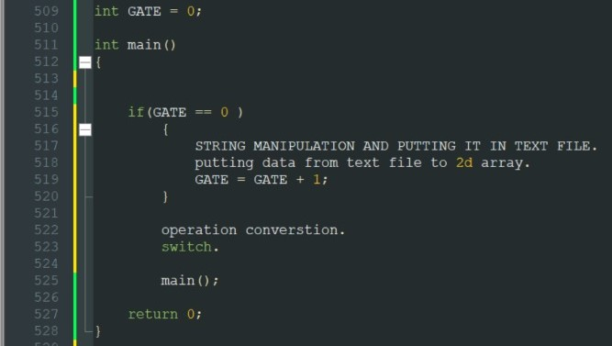

* **Making 2D array for students:**

open text file that contain the final data that will be stored in 2d array, then we will det every line in the text file that represent the data of student, then we will put this data in 2d array in row for every student and the elements represent the number of elements in every student which include the id and the courses that the student enrolled in, now we can use the 2d array in functions 3,6,8 for easier coding.

**NOTE:** all operation tested and worked with these two strings format.

CoursesExams=[101,28/4/2016,A;201,3/5/2016,A;110,5/5/2016,C;103,5/5/2016,A;120,6/5/2016,D;132,7/5/2016,B]

Students=[191001,201;191002,201,101;191003,479,205,201,207,111;191004,500,654,123,207]

* **Operation 1:** this operation prints the number of students by reading the text file then it creates an array to put data in it so it doesn’t change the original input of the user then use strtok() library function which finds semi colon then increase the counter by 1 each loop.
* **Operation 2:**
* **Operation 3**: this operation find the minimum id by putting all id the in the array1[i][0] to the variable ‘minimum’, then will compare the ‘minimum’ with array1 and if the id of ‘array1’ if id in ‘minimum’ is smaller then the program will put id found in ‘minimum’ in array2 [c][0] and the increment the ‘location’ by 1, the tprogram will print the smaller ID.
* **Operation 4:**
* **Operation 5:**
* **Operation 6:** This operation is supposed to print all ID of the students who attend a course which user insert it. The user will choose one of the given courses and the code will calculate and print each student ID who attend this course. By compare the elements in each array in the 2d array with the variable ‘search’ and if the element equal to the variable ’search’ the program will print the position [i][0] of this array which contain the id of the student.
* **Operation 7:**
* **Operation 8:** This operation is supposed to print all student IDs of the students attending less than (n) number of courses. First the users will be prompted using scanf function to enter the student’s data that includes IDs and taken courses. Then the counter that holds the ID numbers (M) will be added by 1 to its value. Then an if statement is made with an array and a condition that if the array value is less than counter (M), the program will print the element in position zero inside the array which holds the student’s ID. Else the program will print none.
* **Operation 9:**
* **Operation 10:**
* **Operation 11:**

when the ‘search’ variable equal to the name Quite it will print thanks and the compiler will return 0; so the program will end.

**Flowchart of execution sequence: -**

* **Operation 1:**

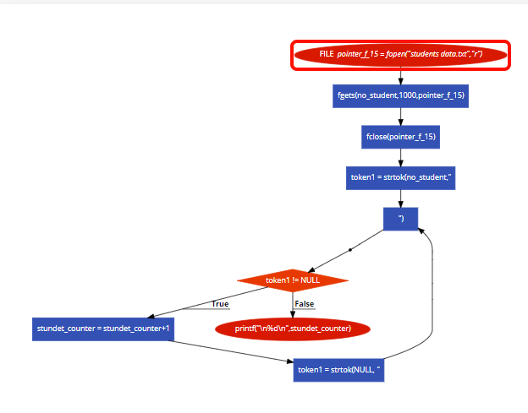

* **Operation 2:**
* **Operation 3:**

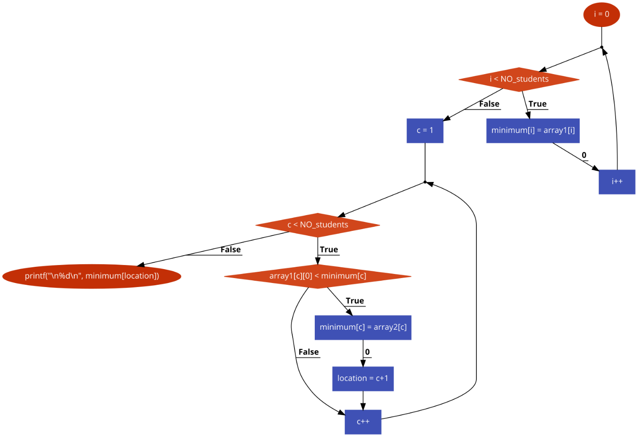

* **Operation 4:**
* **Operation 5:**
* **Operation 6:**

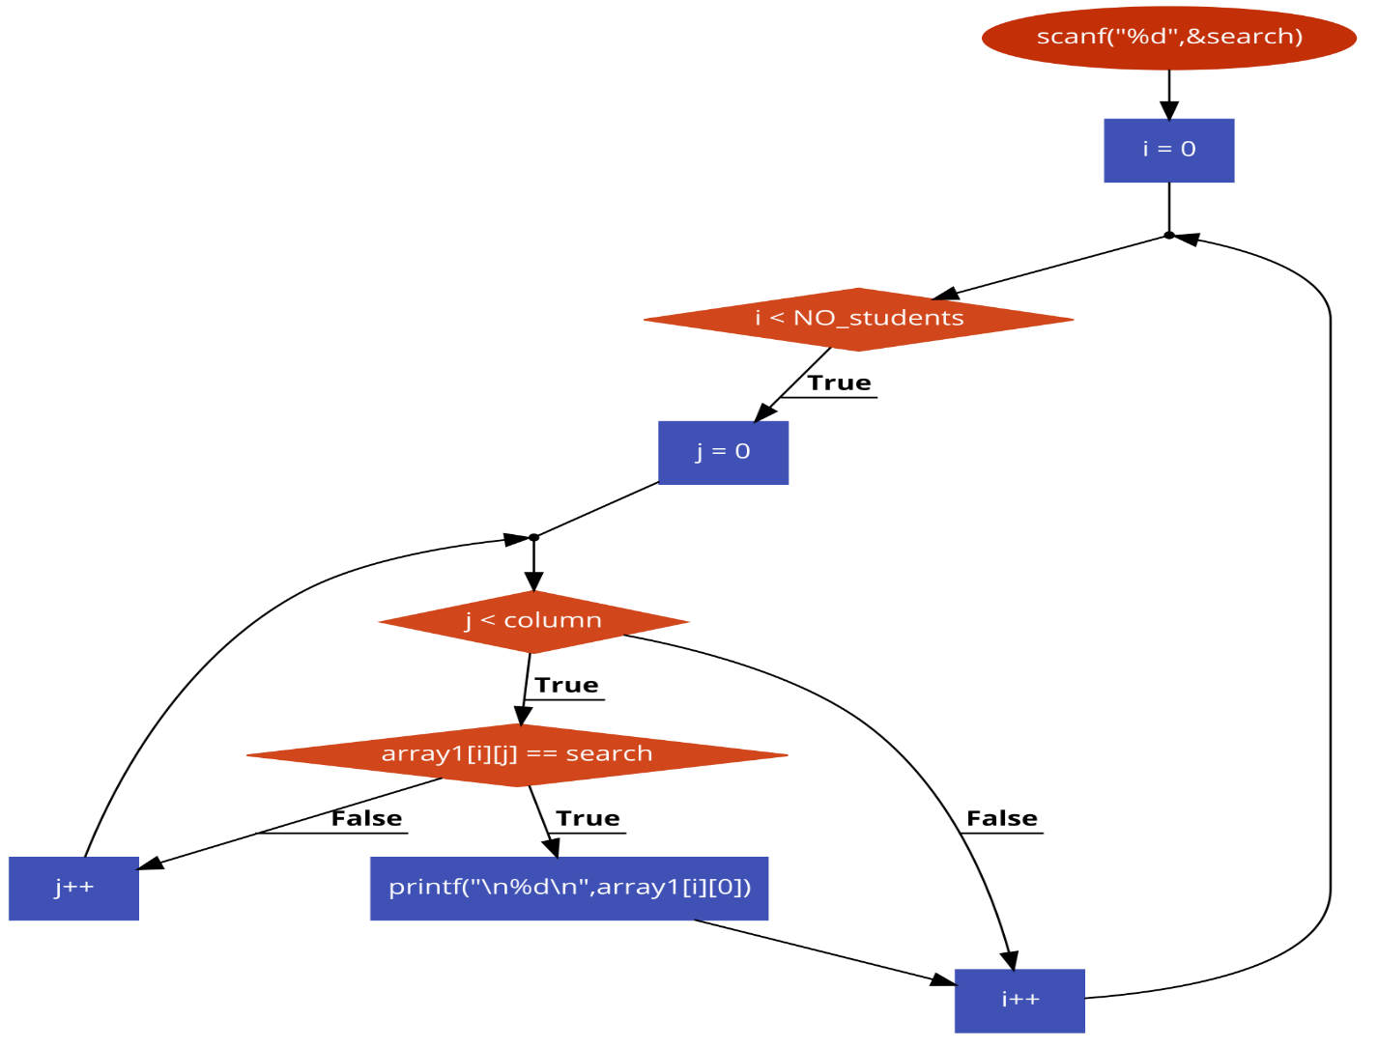

* **Operation 7:**
* **Operation 8:**

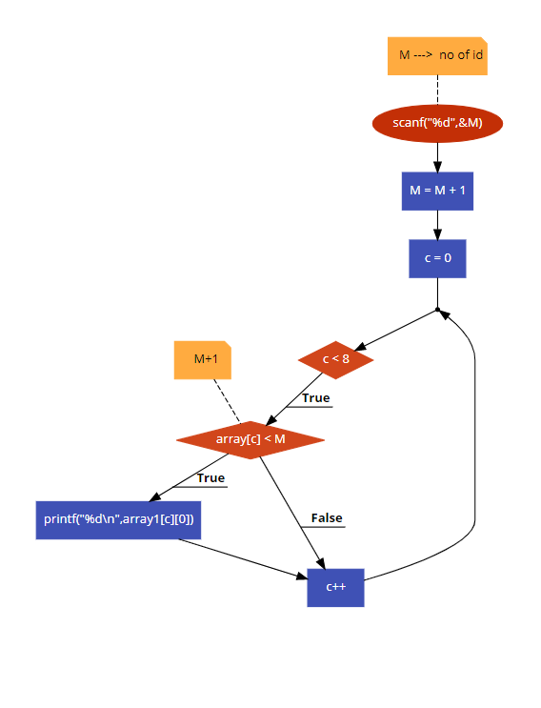

* **Operation 9:**
* **Operation 10:**
* **Operation 11:**

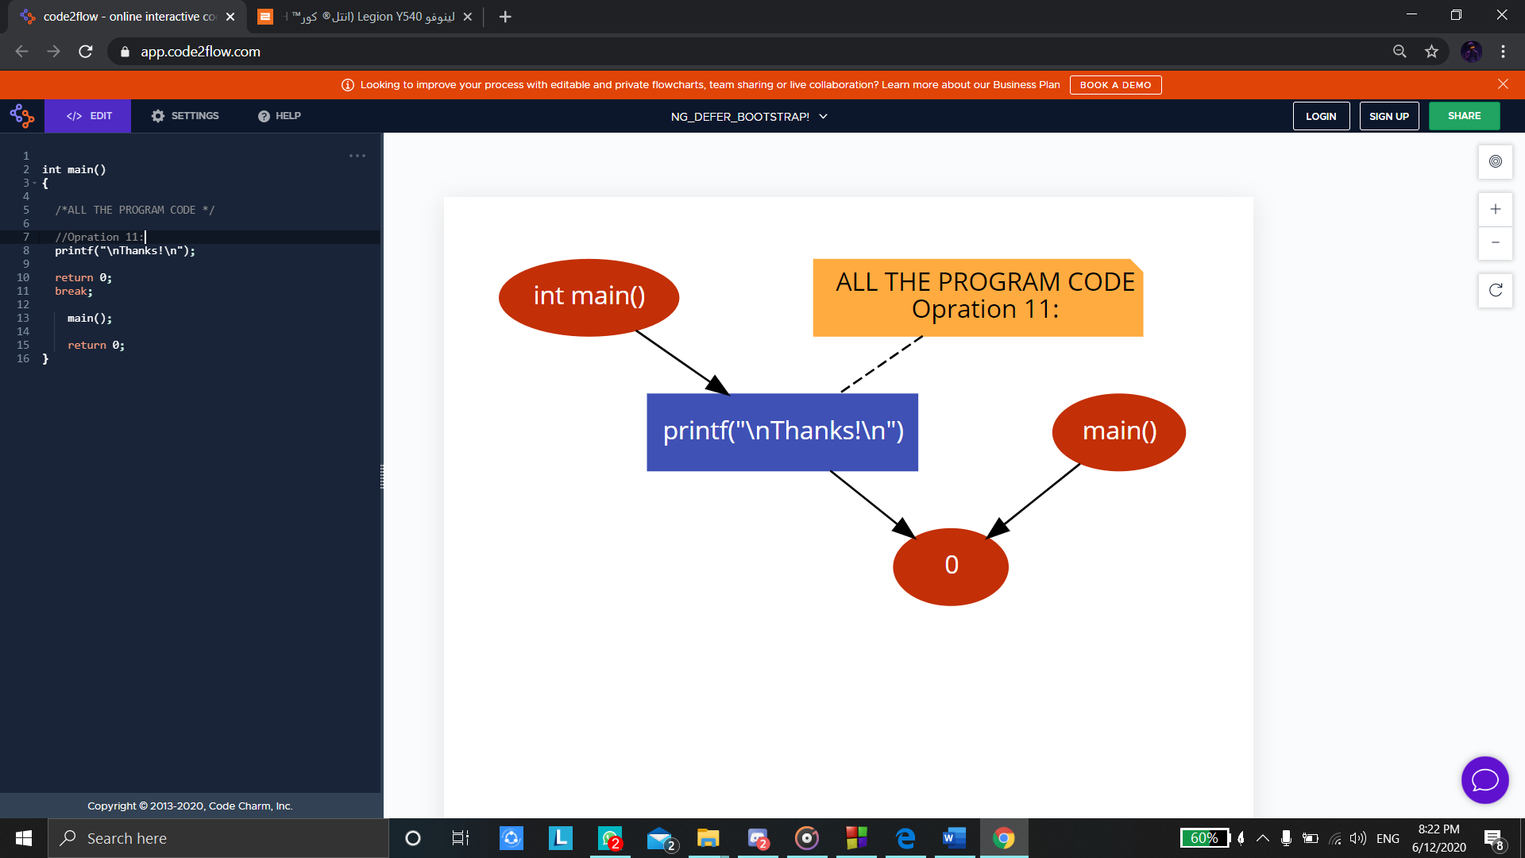

**Sample of Input & Output Screen: -**

* **Operation 1:**

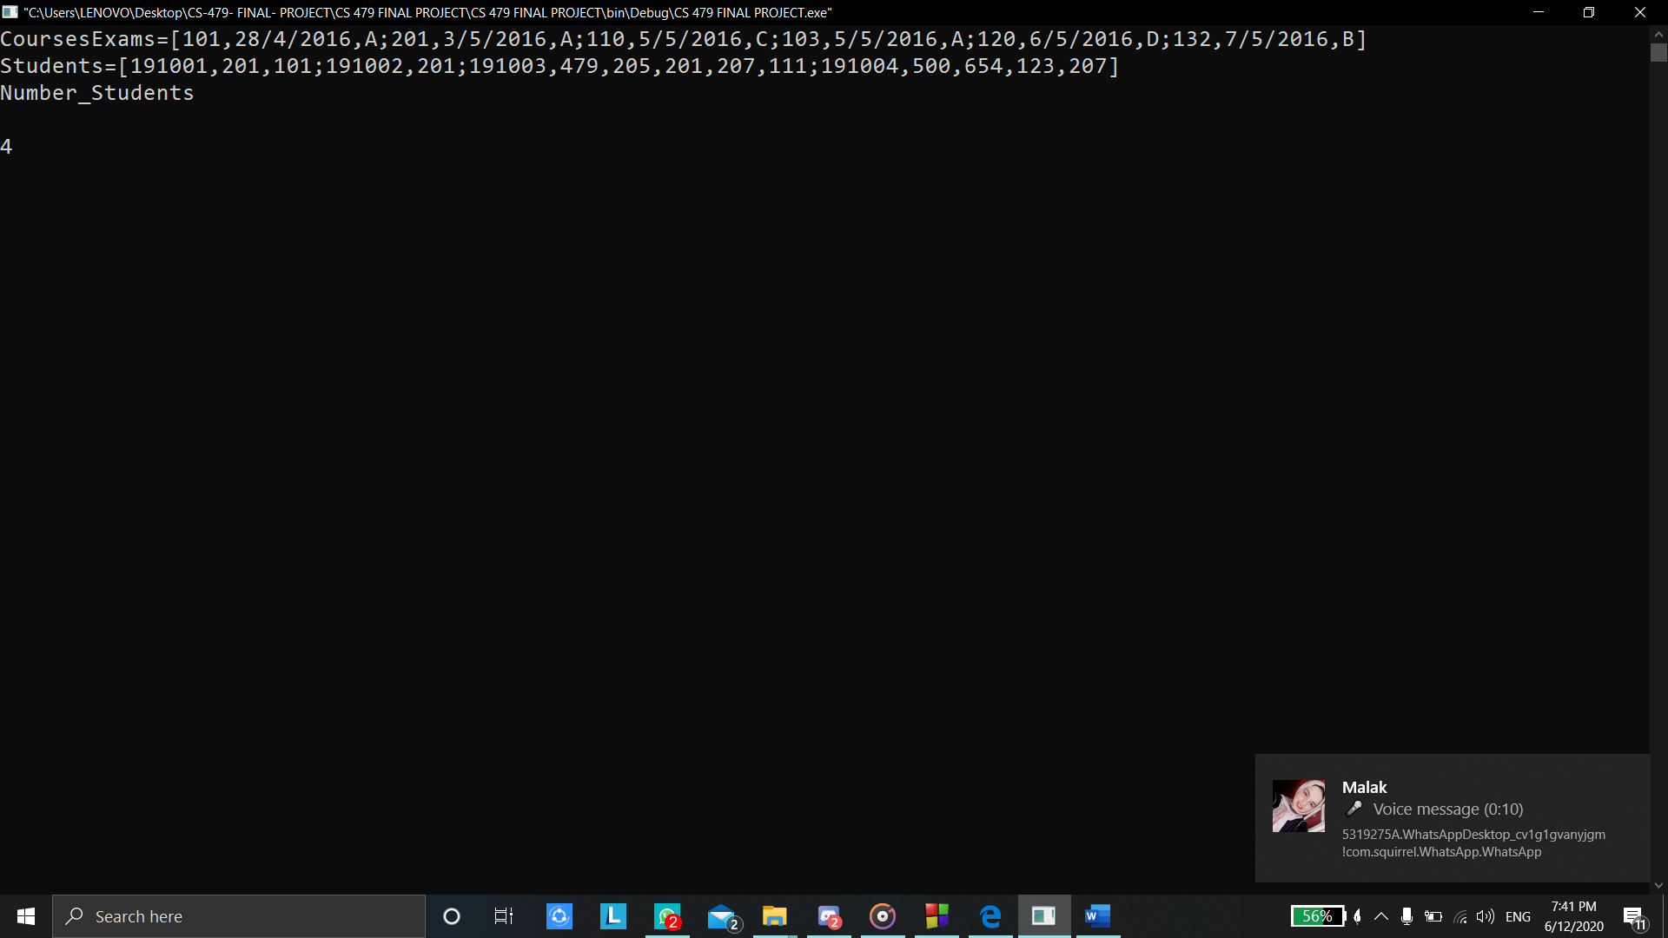

* **Operation 2:**
* **Operation 3:**

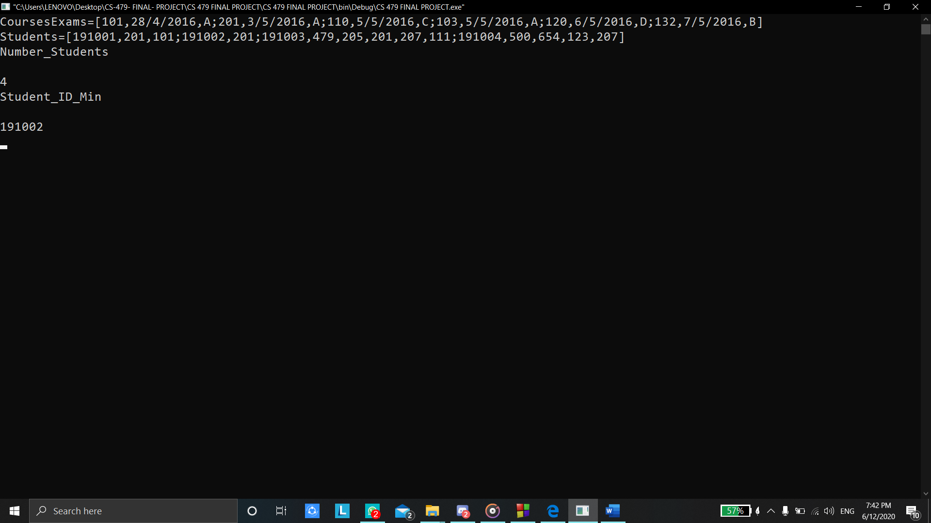

* **Operation 4:**
* **Operation 5:**
* **Operation 6:**

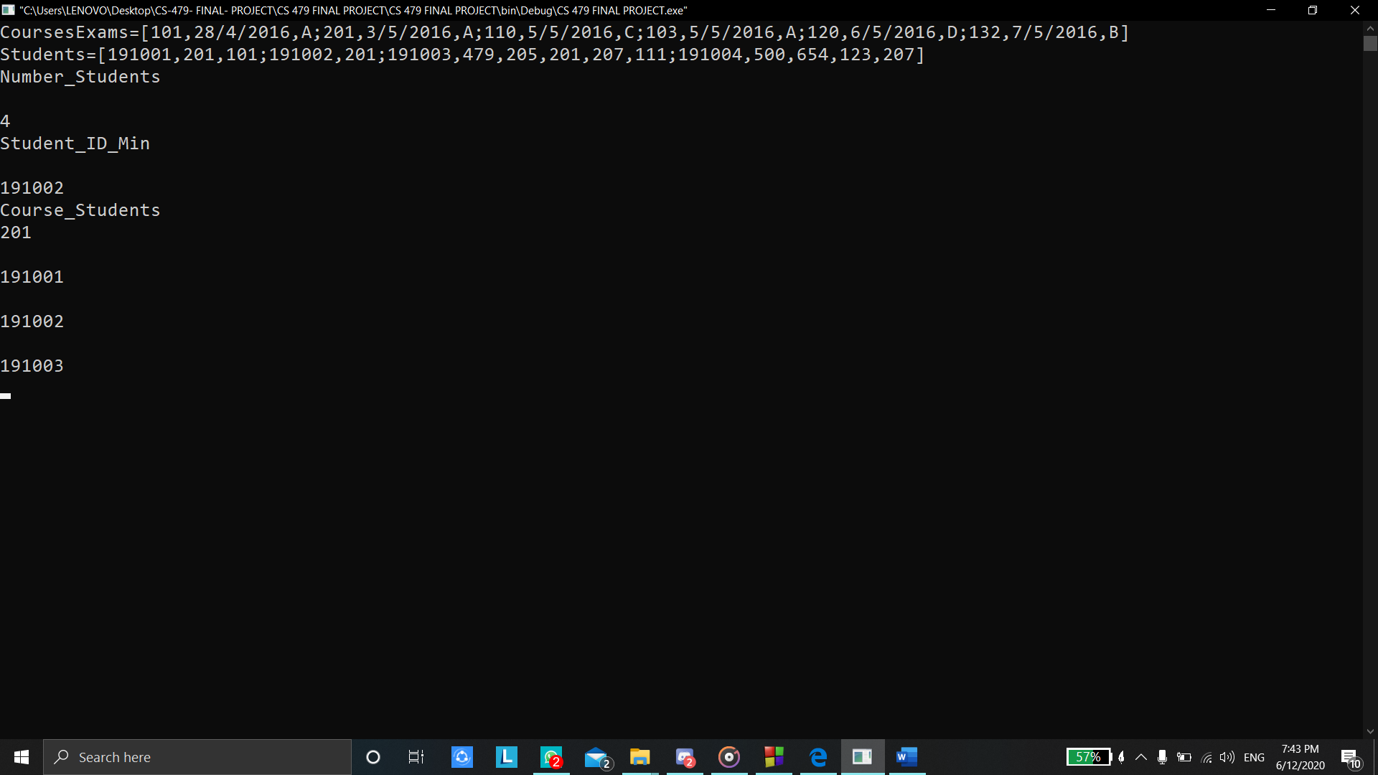

* **Operation 7:**
* **Operation 8:**

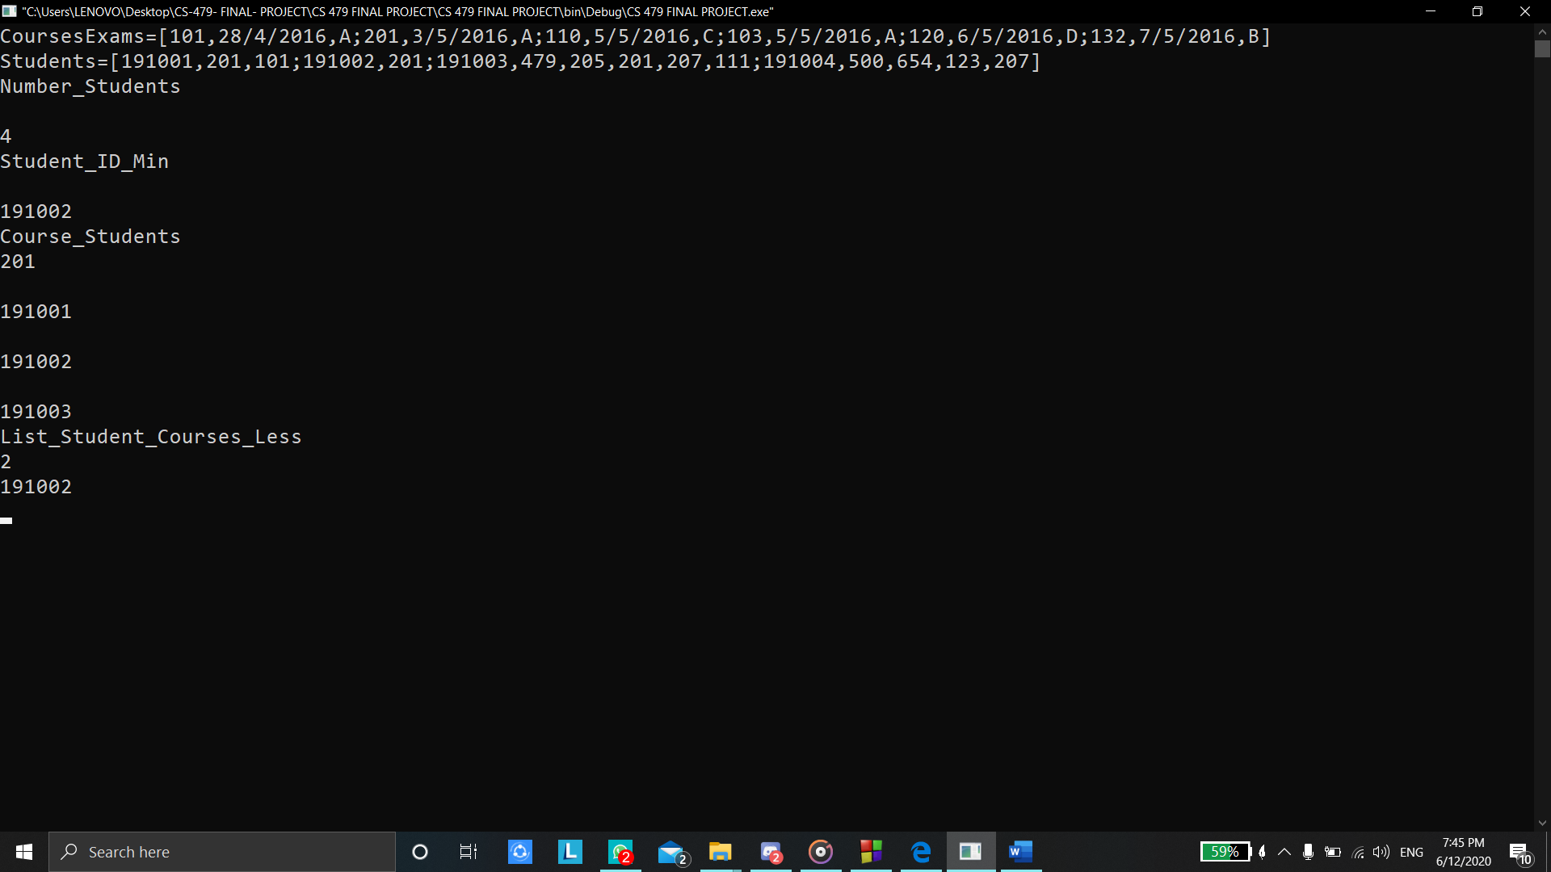

* **Operation 9:**
* **Operation 10**
* **Operation 11:**

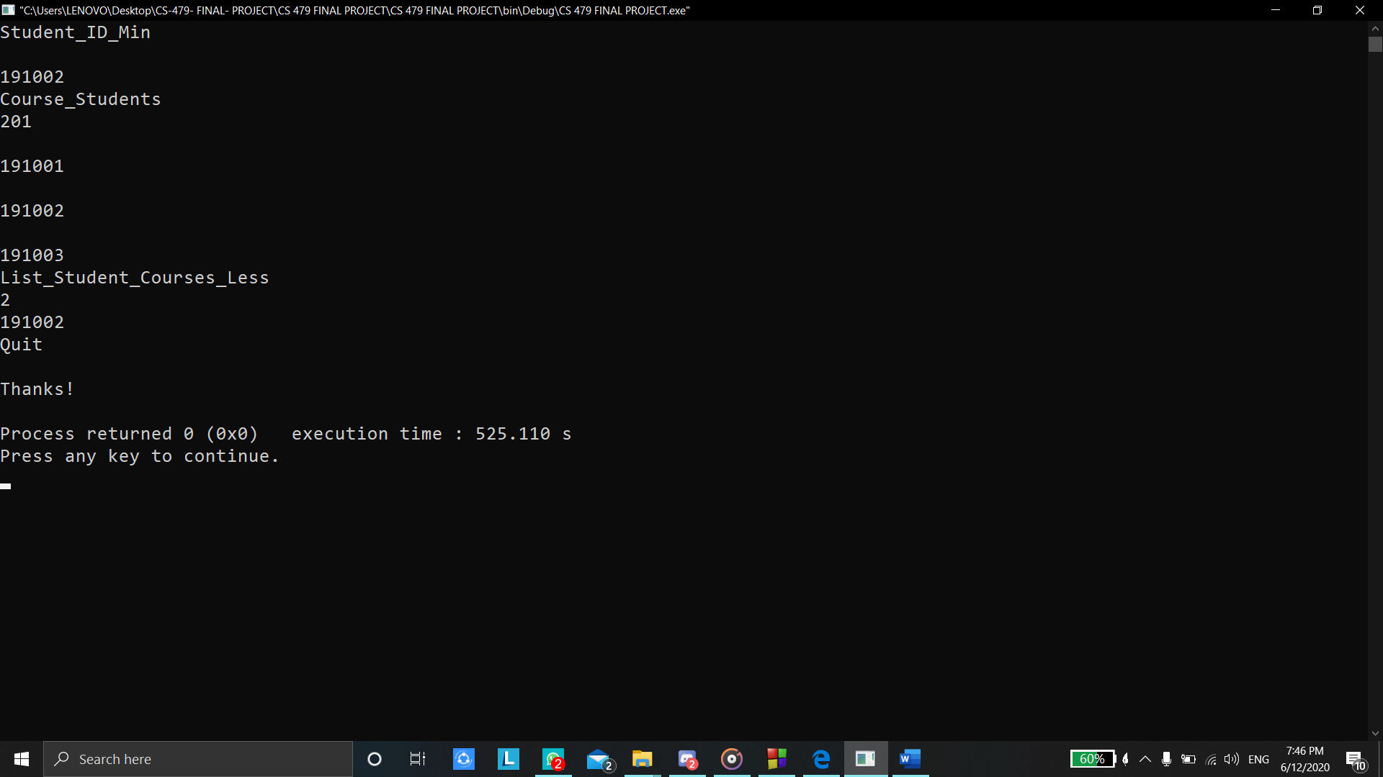

**Text file sample:**

**Steps of manipulation of the student string**

**-Text file Students data. Text sample:**

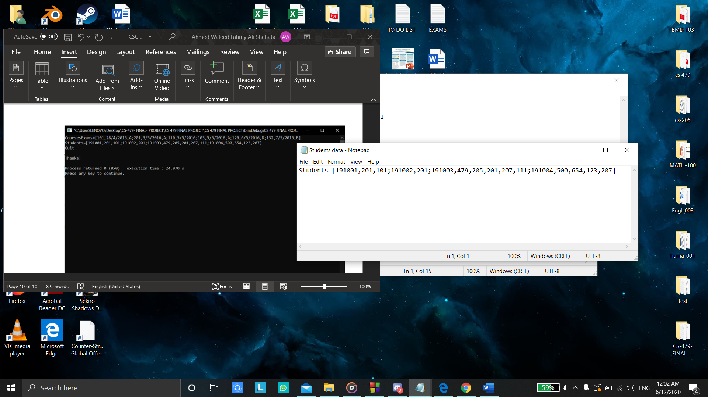

-**Text File data arrange .text sample:**

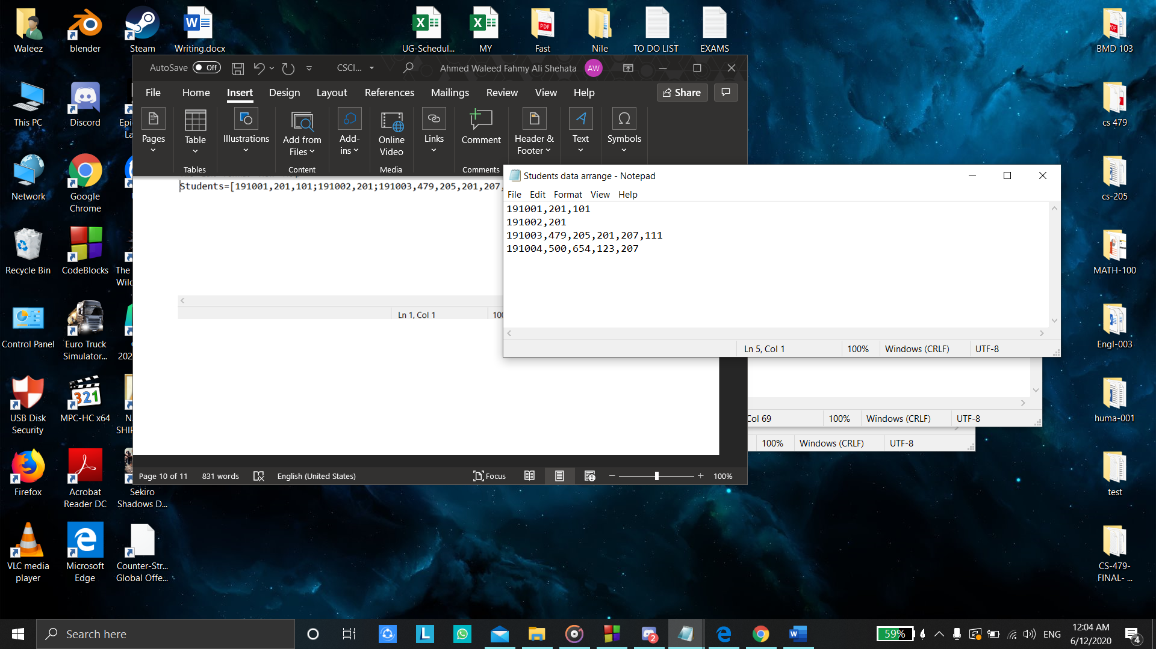

**- Text file CONTAINER.txt sample:**

